./

GENESIS - Learning Outcome & Learning Report



|  |  |  |  |  |  |
| --- | --- | --- | --- | --- | --- |
| **Ver. Rel. No.** | **Release Date** | **Prepared. By** | **Reviewed By** | **To be Approved** | **Remarks/Revision Details** |
| 1. | 2/1/2021 | THIRLUKA VENKATA SAI YAMINI |  |  |  |
|  |  |  |  |  |  |
|  |  |  |  |  |  |
|  |  |  |  |  |  |
|  |  |  |  |  |  |

**Details**

Contents

1.BUILD IMPLEMENTATION……………………………………………………………………………………………………………..4

2.LINKER SCRIPT………………………………………………………………………………………………………………………………6

3.STARTUP CODE…………………………………………………………………………………………………………………………….8

4.MAKE FILE……………………………………………………………………………………………………………………………………11

ACTIVITY 1:

1.BUILD IMPLEMENTATION:

PROGRAM SCREENSHOT:

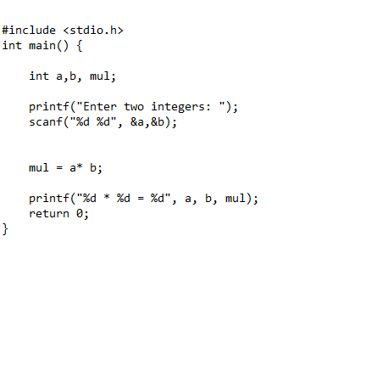

COMMAND PROMPT OUTPUT:

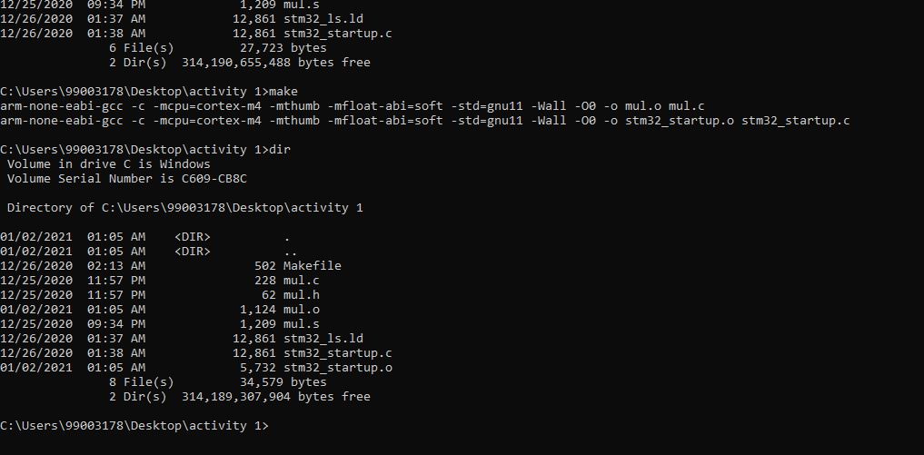

ACTIVITY 2:

2.LINKER SCRIPT SCREENSHOT :

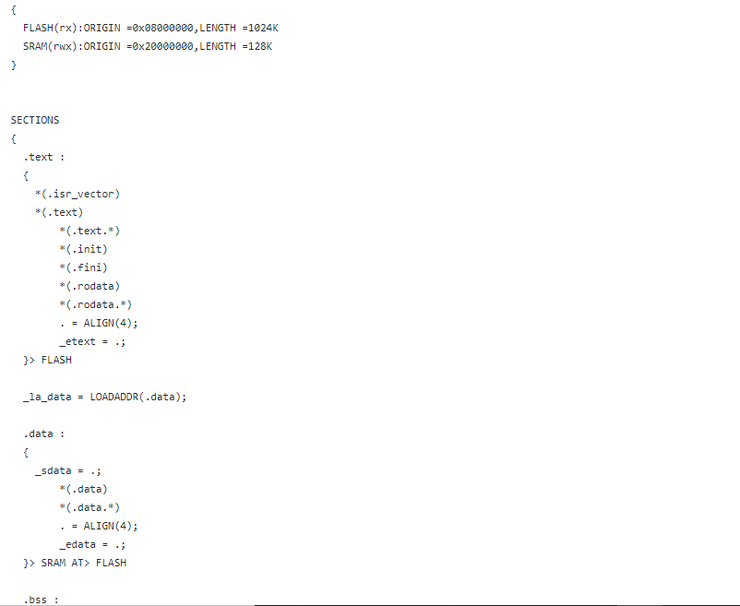

ACTIVITY 3:

3.STARTUP CODE SCRRENSHOT:

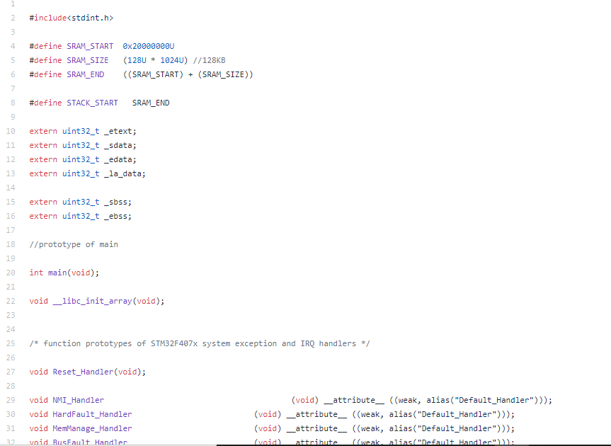

ACTIVITY 4:

4.MAKE FILE SCREEN SHOT:

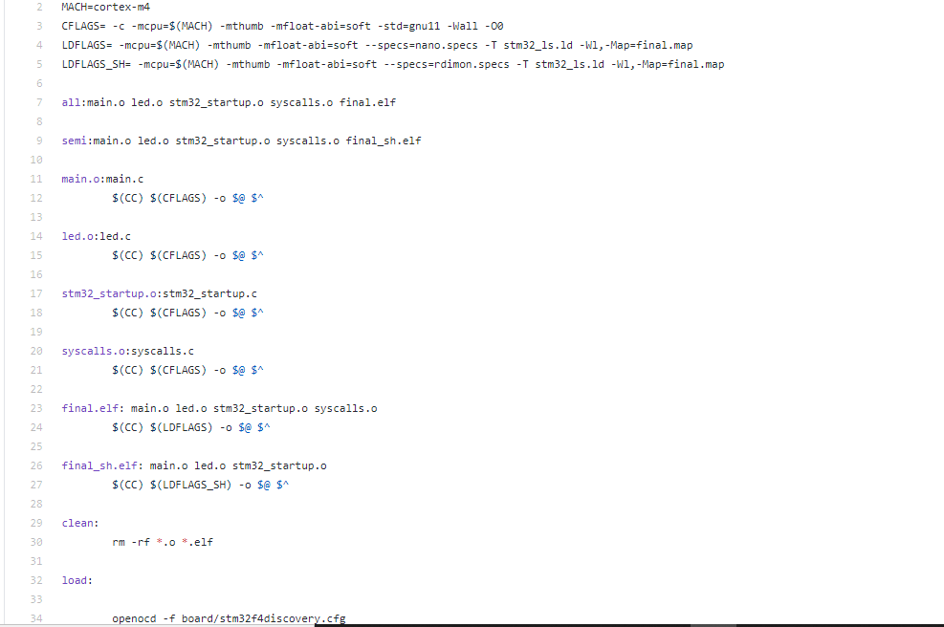

GIT HUB LINK OF ACTIVITES:

<https://github.com/99003178/embedded-activites.git>